Planning System – Flatwire Changes

Add a dropdown either in gray or blue header area to filter “All” or “Regular” or “Back2Back” or “Flatwire” orders. Default value is “All”.
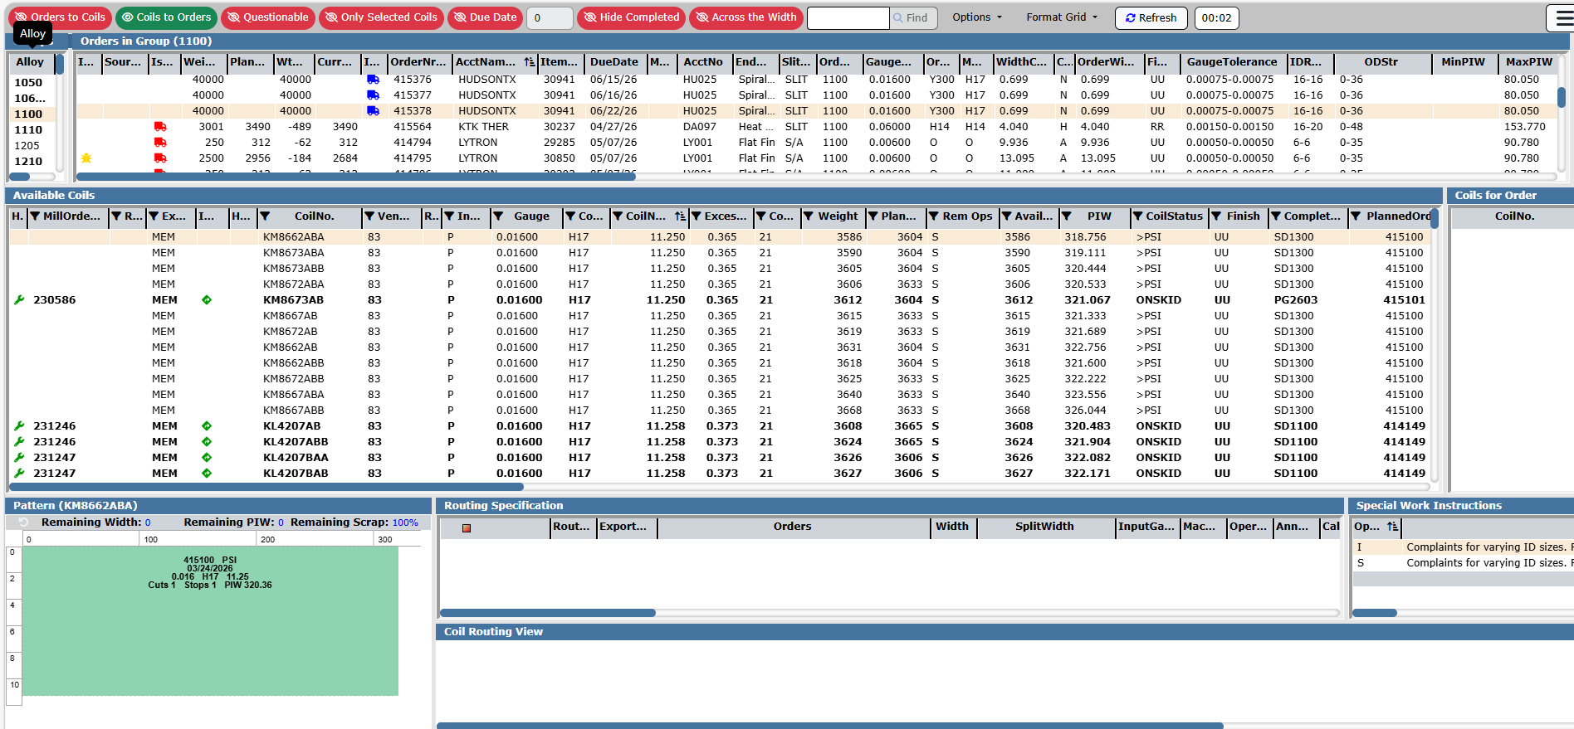
All

Once a flatwire order is selected, the “Available Coils” section should be changed to show new headers – “CoilNo” should be shown as “Coil/Bundle No.” and “Gauge” to “Gauge/Diameter”. This section should only see material relevant to the order’s item template (same as coils show up currently).

When a material is dropped onto an order, the View pop-up does not need Number of Cuts or Number of Stops. It just needs a “Weight” field for planners to indicate how much weight from a spool/bundle is going to be assigned to the order. System has to generate an alpha for the remainder of the spool going back to warehouse.
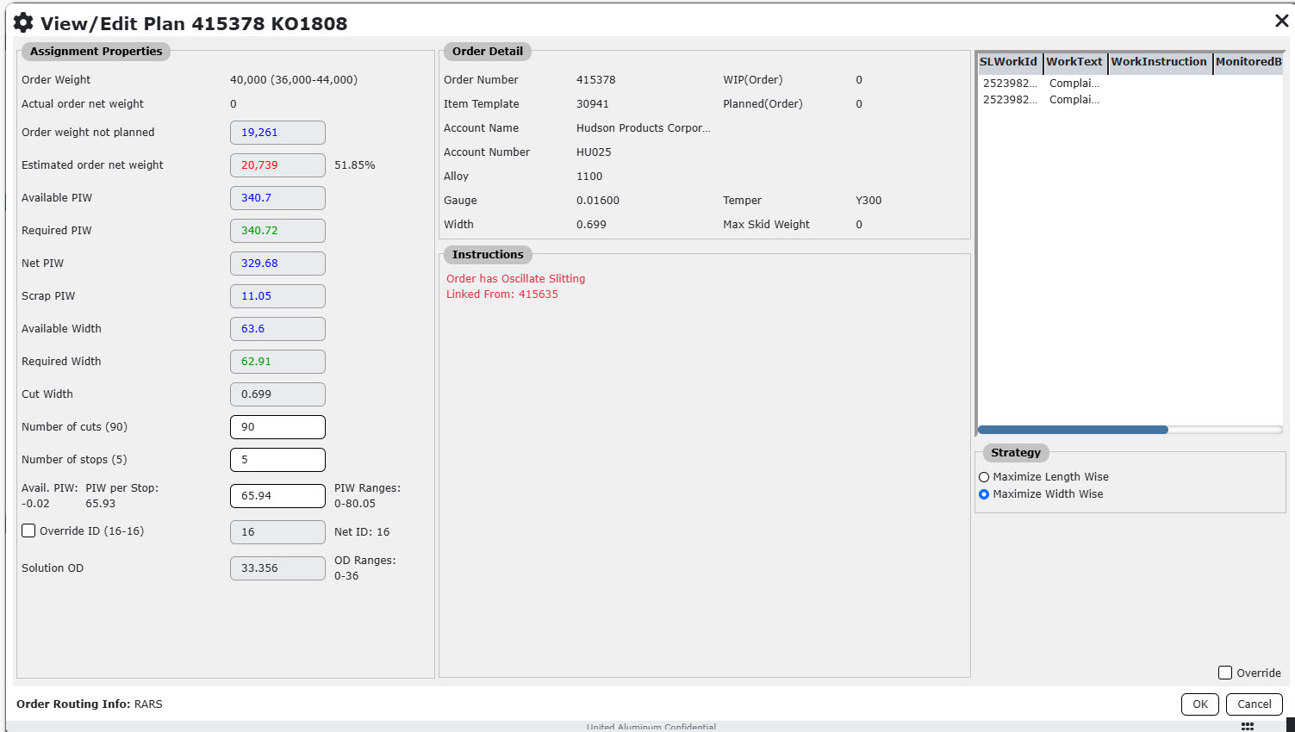

Picture in the pattern (bottom left) need not be shown, as it is no longer a rectangular pattern. Planners are ok with leaving that area as blank.

